Ecommerce Project

- Goal: Analyse the sales performance of products, categories, and regions.
- Database Schema Overview: We have 5 tables:
- Customers
- Products
- Orders
- OrderDetails
- Regions

E-commerce Sales Analysis Project – Key Business Insights
In this project, I analysed an e-commerce database containing customer, product, order, order details, and regional data. Using SQL for data analysis and Power BI for visualization, I generated several business insights.
1. Revenue Performance
- Calculated total revenue and tracked revenue growth by month and year.
- Identified seasonal sales trends and peak-performing periods.
- Measured Average Order Value (AOV) to understand customer spending patterns.
Business Impact: This helps management forecast sales, plan promotions, and set revenue targets.
2. Customer Analysis
- Identified the top 10 customers based on total spending.
- Calculated the repeat customer rate to measure customer loyalty.
- Segmented customers into Platinum, Gold, Silver, and bronze categories based on their lifetime spending.
- Estimated Customer Lifetime Value (CLV) to identify high-value customers.
Business Impact: These insights support personalized marketing campaigns and customer retention strategies.
3. Product Performance
- Identified the top-selling products by quantity and revenue.
- Analysed category-wise sales performance.
- Detected products with high return rates.
Business Impact: This helps optimize inventory, focus on high-performing products, and improve product quality.
4. Regional Performance
- Compared revenue and order volume across different regions.
- Calculated Average Order Value by region.
- Analysed regional return rates.
Business Impact: The business can identify strong markets, improve weaker regions, and allocate marketing budgets more effectively.
5. Return Analysis
- Measured overall return rates.
- Identified categories and products with frequent returns.
- Found customers with unusually high return frequencies.
Business Impact: This helps reduce losses, improve customer satisfaction, and identify potential fraud or product quality issues.
6. Dashboard Development
I created an interactive Power BI dashboard with KPI cards, bar charts, line charts, pie charts, and slicers. Users can filter data by year, month, category, and region to explore sales performance dynamically.
Overall Outcome
The project transformed raw transactional data into meaningful business insights that support strategic decision-making in sales, marketing, inventory management, and customer relationship management.

Questions:
- General Sales Insights
  - What is the total revenue generated over the entire period?

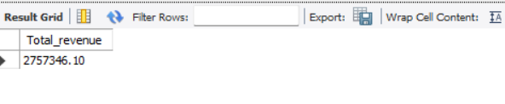
  - Revenue Excluding Returned Orders
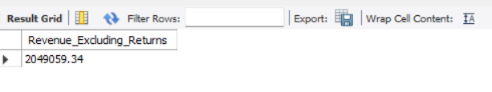
  - Total Revenue per Year / Month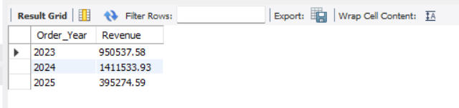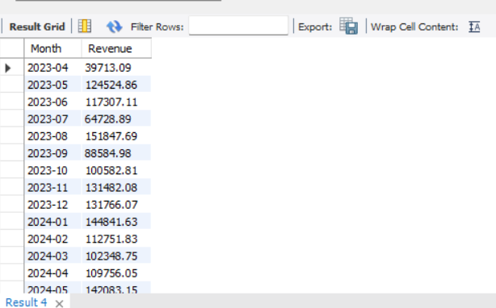
  - Revenue by Product / Category

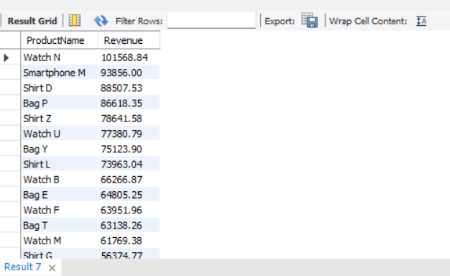
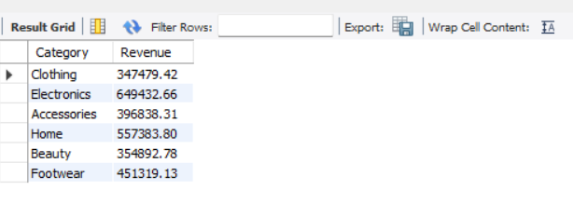
  - What is the average order value (AOV) across all orders?
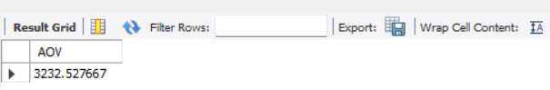
  - AOV per Year / Month
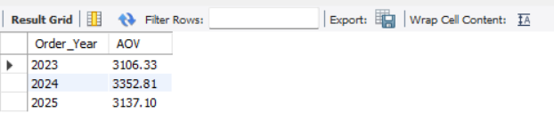

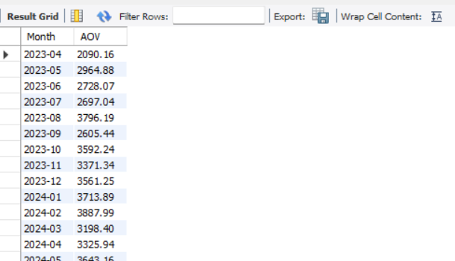
  - What is the average order size by region?
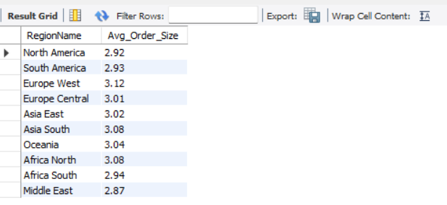

- Customer Insights
  - Who are the top 10 customers by total revenue spent?
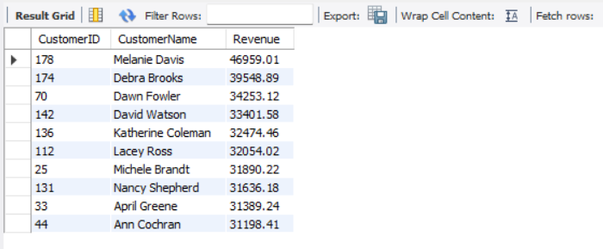
  - What is the repeat customer rate?
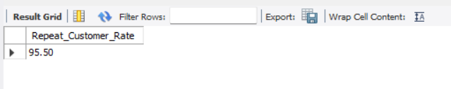
  - What is the average time between two consecutive orders for the same customer Region-wise?
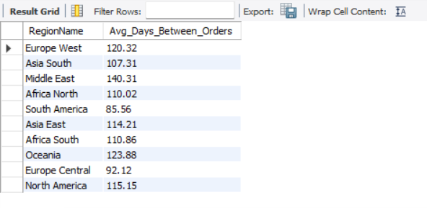
  - Customer Segment (based on total spend)
    - Platinum: Total Spend > 1500
    - Gold: 1000–1500
    - Silver: 500–999
    - Bronze: < 500
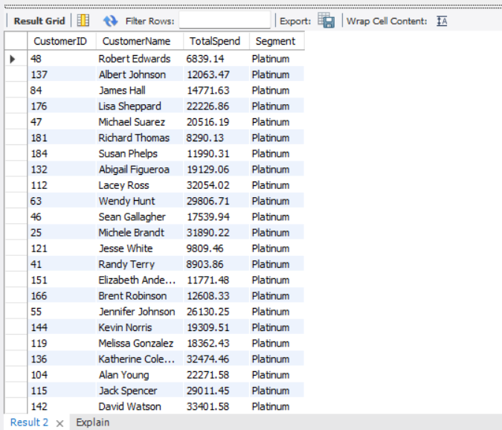

  - What is the customer lifetime value (CLV)?

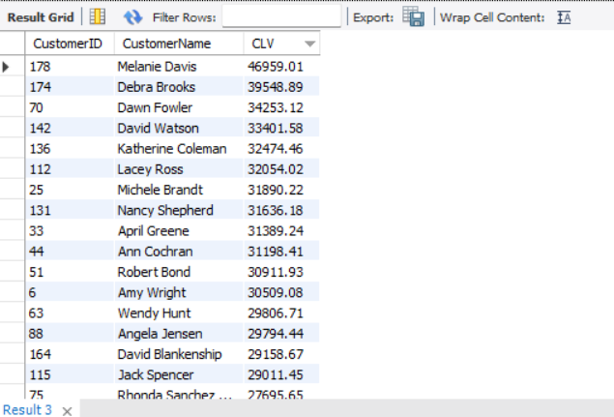

- Product & Order Insights
  - What are the top 10 most sold products (by quantity)?
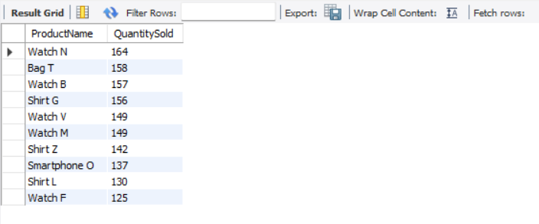
  - What are the top 10 most sold products (by revenue)?
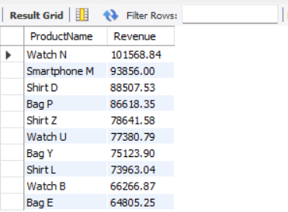
  - Which products have the highest return rate?
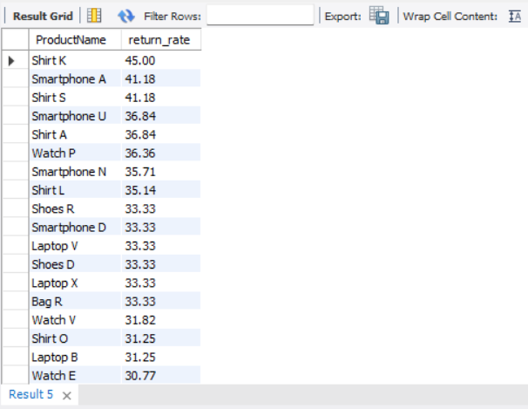
  - Return Rate by Category
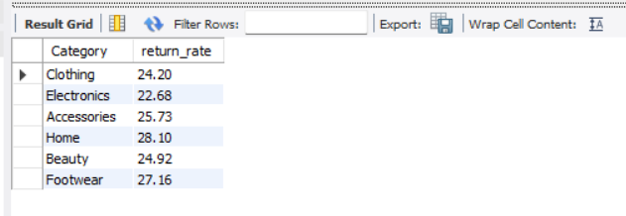
  - What is the average price of products per region?
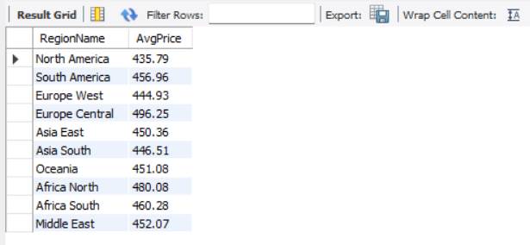
  - What is the sales trend for each product category?
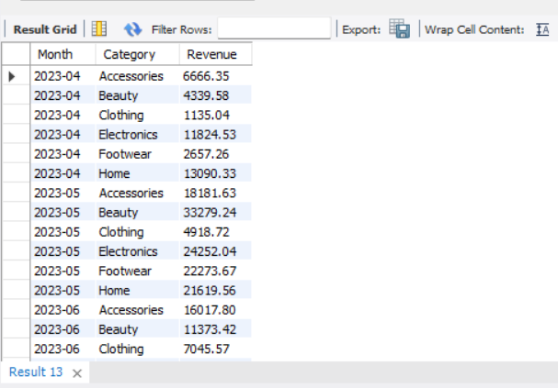

- Temporal Trends
  - What are the monthly sales trends over the past year?
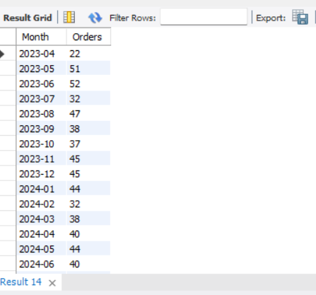

  - How does the average order value (AOV) change by month or week?
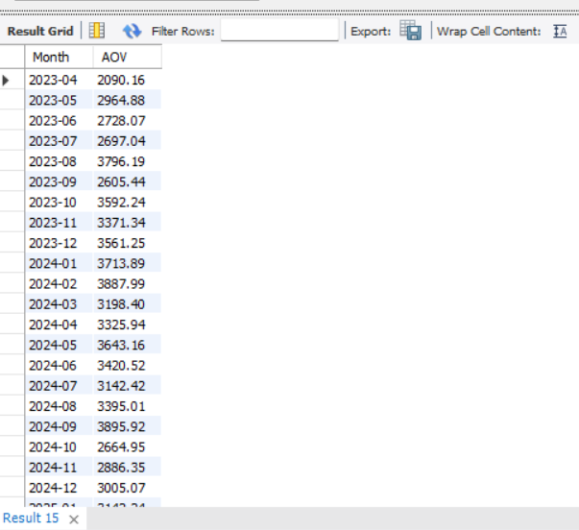
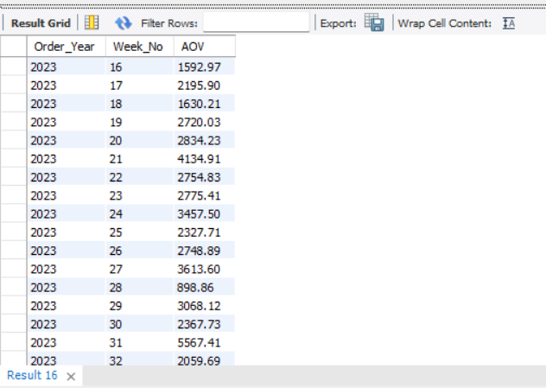

- Regional Insights
  - Which regions have the highest order volume and which have the lowest?
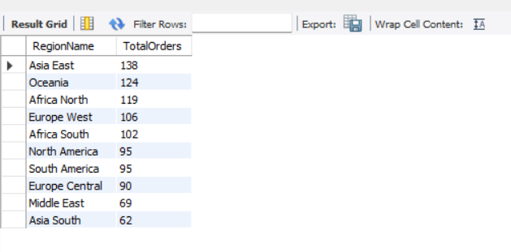
  - What is the revenue per region and how does it compare across different regions?

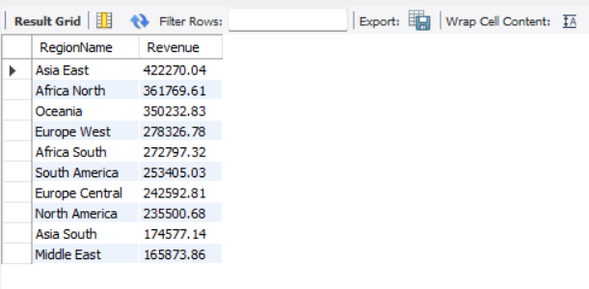
- Return & Refund Insights
  - What is the overall return rate by product category?
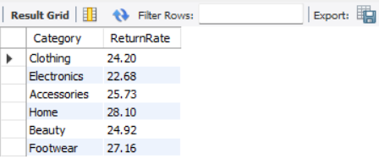
  - What is the overall return rate by region?
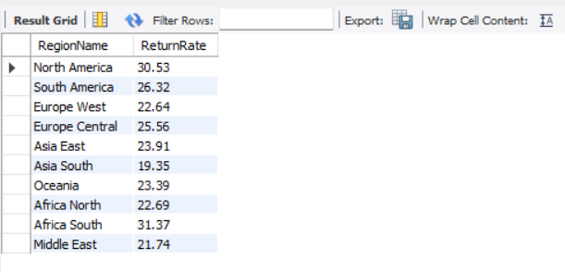
  - Which customers are making frequent returns?

